**Assignment No. : 06**

**Title:** Use Business intelligence and analytics tools to recommend the combination of share purchases and sales for maximizing the profit.

**Aim:** Use Business intelligence and analytics tools to recommend the combination of share purchases and sales for maximizing the profit.Use Business intelligence and analytics tools to recommend the combination of share purchases and sales for maximizing the profit.

**Objectives:**

* To study the Business intelligence.
* To study the analytics tools.

**Theory:**

Go to the Fact Orders sheet of the Northwind Traders data workbook. Individually select all values in the columns OrderDate, RequiredDate and ShippedDateand paste them in one single column in a new sheet. The below 2

snapshots will assist you in doing the same.

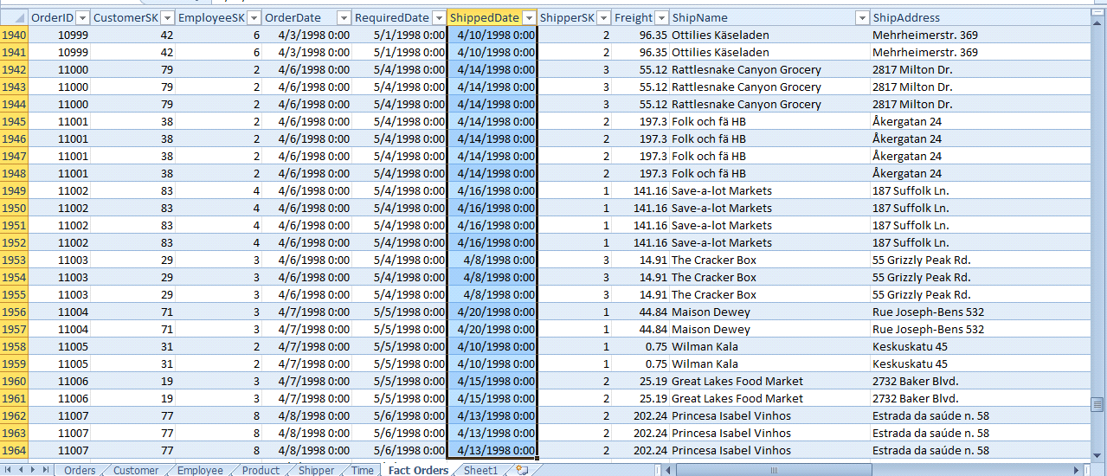

Figure 1: Output

Once all the dates are copied, select the data tab, select the Remove Duplicates option and click OK twice. Use the Month and Year Excel functions to fetch the corresponding month numbers and years from the dates. Make sure all the dates have the respective month numbers and years in the adjacent columns as shown below in the 2 snapshots.

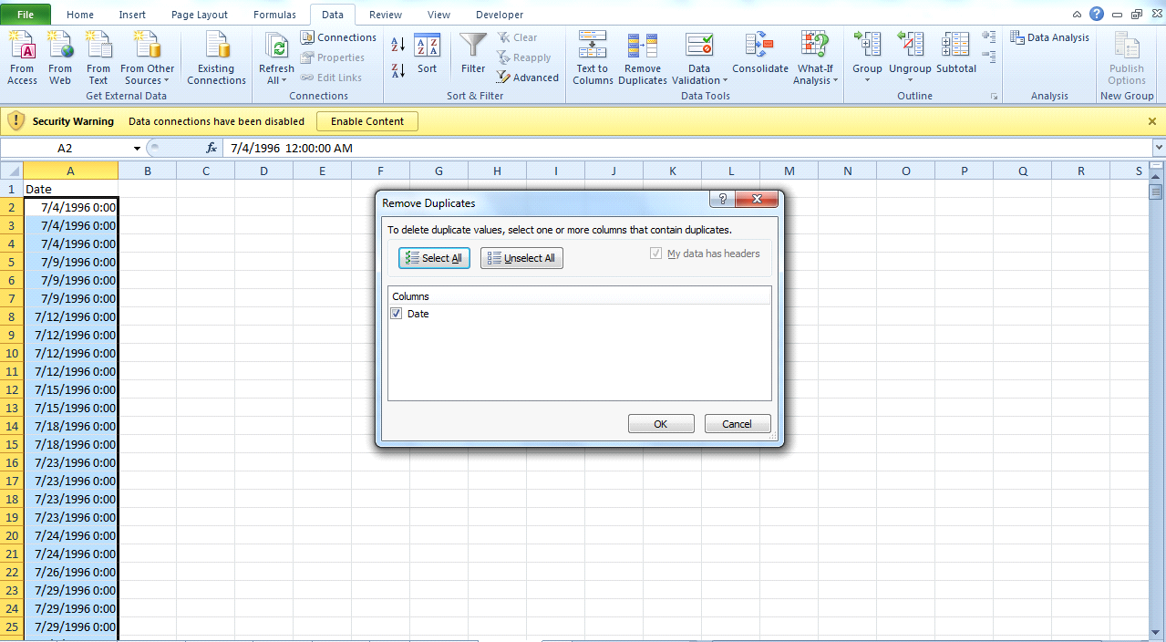

Figure 2:Output

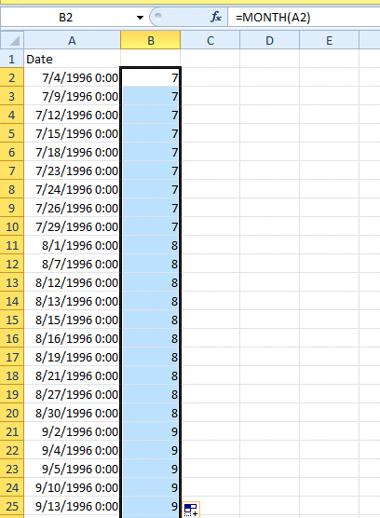

Figure 3: Output

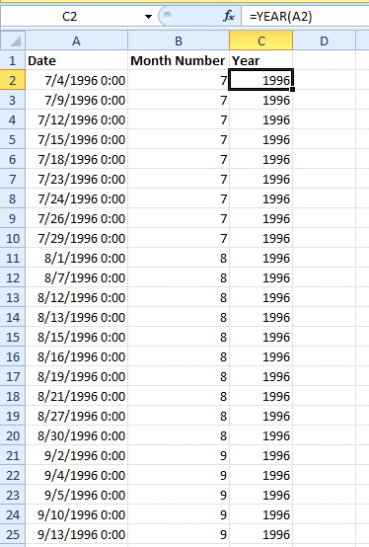

Figure 4: Output

Create a dataset in a new excel sheet as shown below:

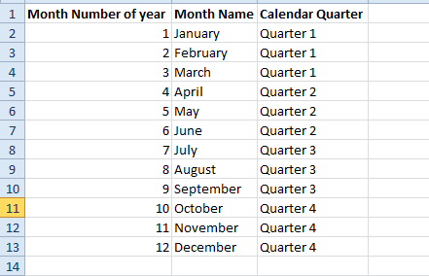

Figure 5: Output

Select the entire dataset and name it as?Time in the Name Box as shownbelow. Do not forget to hit Enter once name is typed in the name box.

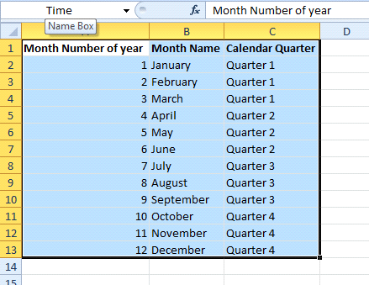

Figure 6: Output

In the sheet where we have the Date, Month Number and Year, add a newcolumn ? ?Month Name? and type the vlookup formula as shown below;

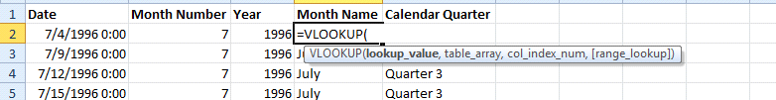

Figure 7: Output

Follow the same procedure for Calendar Quarter and use the formula=vlookup(B2,Time,3,False).

Organizing and Analyzing the Data When we have a large amount of data,we want to organize it, analyze it, get summary information and then graph it.We need analytical tools for this, and the PivotTable and PivotChart tools in Microsoft Excel are some of the most popular tools. The data does not need tobe in one workbook. We may analyze data from multiple workbooks withouttoo much trouble.

Basics of PivotTables Pivot Tables allow us to consolidate huge amounts of data with similar fields and analyze the consolidated data or just make asummary of the consolidated data. The PivotTable in Excel gives us a simpleway to create a PivotTable for our data. Please note that the data should haveat least 1 field in common, or else the consolidation will not work and any spelling error in the data will produce incorrect PivotTables. PivotTables inExcel are synonymous to Cubes in other analytical tools.Basics of Charts are used to graphically represent data. The PivotChart tool in Excel provides a simple way to create a PivotTable and anaccompanying chart. Remember, a chart is only as good as the data or thesummary table (PivotTable). If we try to cram too many fields into a chart,we will end up with a non-informative chart. We must always try and keep itsimple and informative.Let us see some scenarios which explore the different ways of analyzing theNorthwind data.

Scenario 1: Graph the percentage sales over time to see the trends.

Here is the answer:

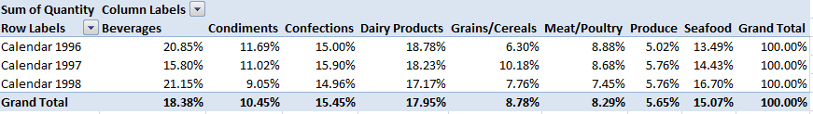

Figure 8: Output

Creating a PivotTable and PivotChart

1. Open the Northwind Traders data.xlsx workbook.

2. Go to the Insert tab on the ribbon.

3. Look for the Tables group, and select PivotTable. Choose PivotChart

from the drop-down options.

4. You should now see the Create PivotTable with PivotChart dialog box.

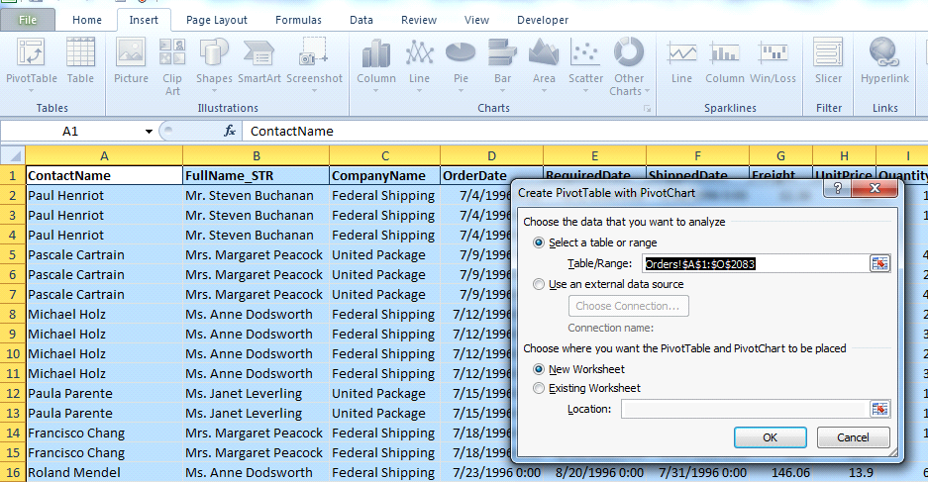

Figure 9: Output

5. There are a couple of things you?ll need to de_ne in order to create yourPivotTable. First, you need to tell Excel where to get the data from. Inthe Choose the data you want to analyze section of the dialog box, youwill define where Excel is going to get the data for the PivotTable from.

Since the data for this example is within the workbook, we will chooseSelect a table or range.

(a) Under Table/Range, Excel might be smart enough to automaticallyselect the proper range of data from the worksheet.

(b) If it does not, click on the little button on the right of the range box.Select the range of data. In the example, we have data in cells A1 toO2083. This means that we have selected fifteen columns (A throughO) and 2083 rows.

6. In the Choose where you want the PivotTable and PivotChart to be placedsection of the dialog box, you can choose to either create the PivotTableand the accompanying PivotChart on a new worksheet in the Excel work-book, or you can place both on the current worksheet. For this exercise, wewill choose to create a new worksheet for the PivotTable and PivotChart.To do this, select New Worksheet, and click OK. You should now be takento the new worksheet.

1. While on the new worksheet, you should see four new tabs on the ribbon:

(a) Design, Layout, Format, and Analyze.

(b) You should also see the PivotTable Field List and the PivotChartFilter Pane (if you dont see the panes, click on the Analyze tab inthe ribbon, and, in the Show/Hide group, make sure that at leastField List is selected).

2. You now need to set up the PivotTable so that you can get the data summary you desire. The new tabs, as well as the two panes, will be used tohelp format your PivotTable and PivotChart to do the necessary analysis.For this exercise, let‟s see the total number of products sold by category ineach year. In the PivotTable Field List, select Quantity, Year and CategoryName to add to the PivotTable report. Place the CategoryName in the Legends field, Year in the Axis Field and Quantity in the Value field. Youshould see the PivotTable and PivotChart update appropriately. Selectthe chart type as Stacked List to get the chart as shown below

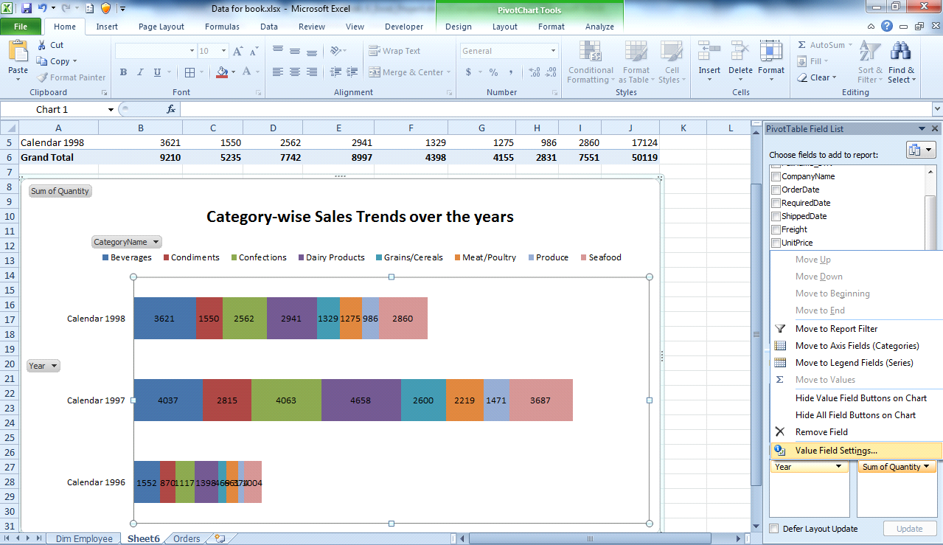

Figure 10: Output

You can use di_erent functions on the _eld placed under Values. For example, if you wanted to see average quantity for each category, you would click on Sum of Quantity and choose Value Field Settings. In the Value Field Settings dialog box, choose the ?Show Values As? tab and select the % of Row Total function to apply to Sum of Quantity (see the screenshot below). A number ofothe functions are available here to use in your PivotTable.

Scenario 2: Pivot the data to see total sales by quarter and category. Arethere any highs? Are there any lows that need to be addressed? Here is the solution:

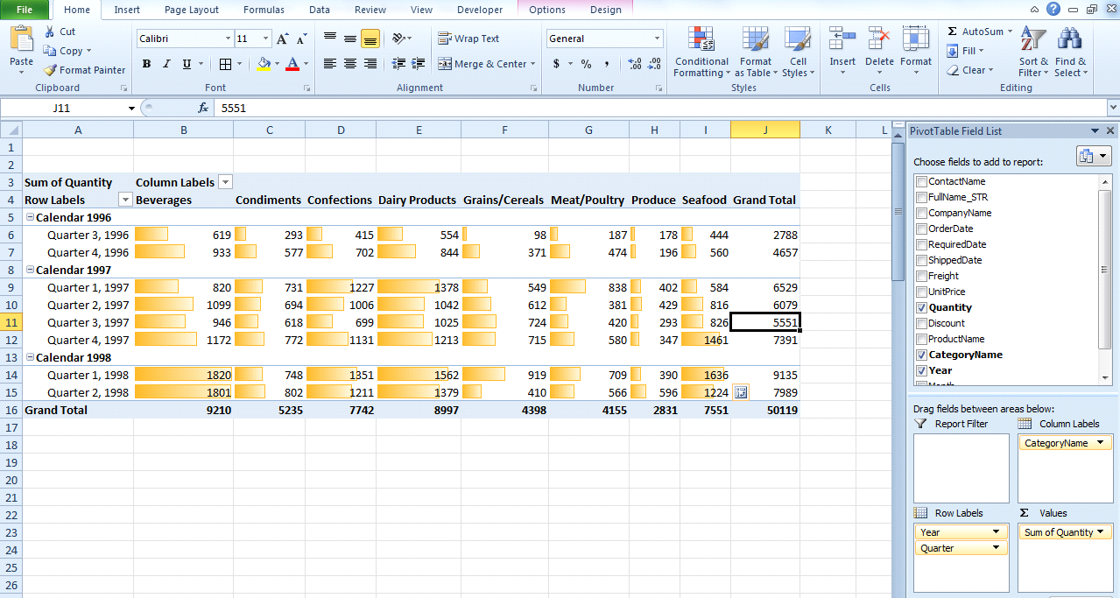

Figure 11: Output

Here is how we do it:

1. Select the the entire table in the Orders worksheet.

2. Go to the Insert menu, select PivotTable.

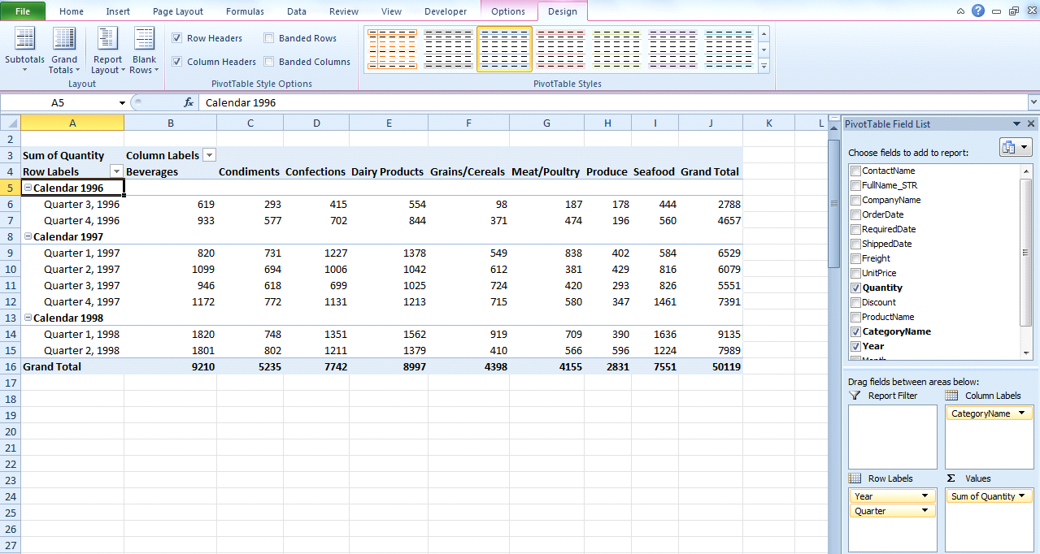

Figure 12: Output

3. Select the columns as highlighted in the circle below (make sure Quantityis represented as Sum of Quantity. Else use the previously used ValueField Settings option to sum it).

4. Select the data as shown in the screenshot below

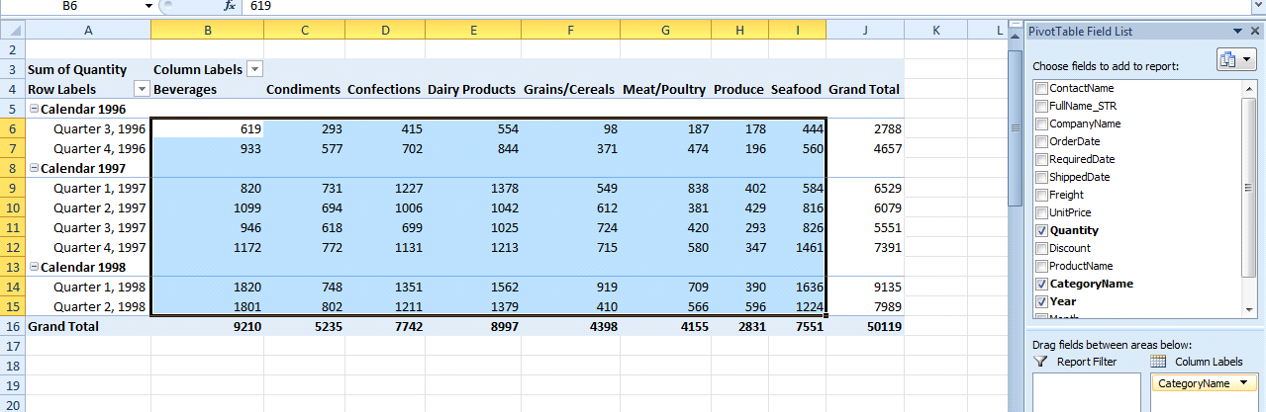

Figure 13: Output

5. Apply the conditional formatting as shown below. (Make sure you are inthe Home menu to view the Conditional Formatting tab)

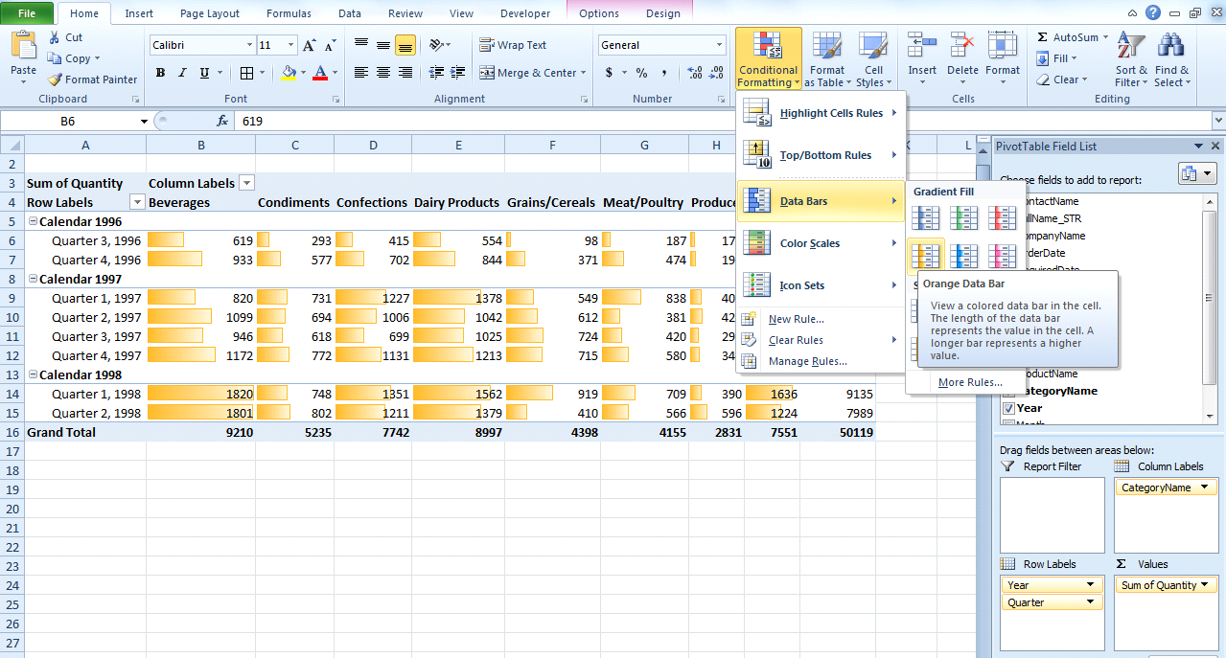

Figure 14: Output

By applying conditional formatting we are able to achieve better visualisationof data. It can be observed that the 2nd quarter of 1998 had the highest totalsales and also the beverages category had the highest total sales for all years,closely followed by dairy products.

Scenario 3: How are quarterly sales totals by salesperson? Subtotal thedata. Here is the answer:

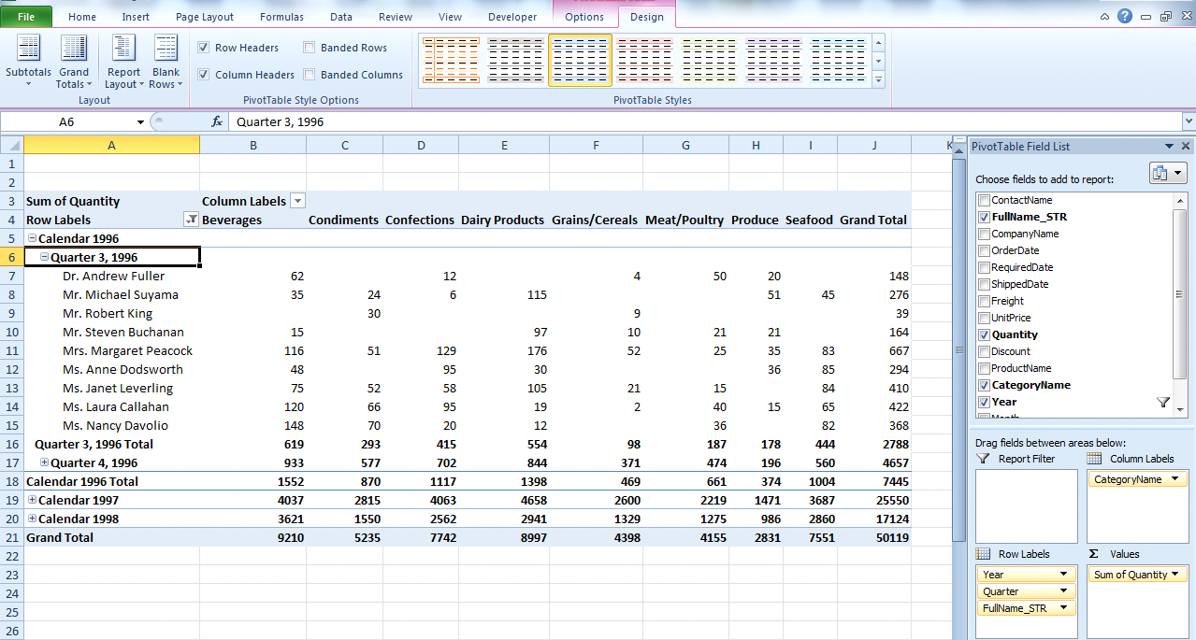

Figure 15: Output

Here is how it is done:

Just drag and drop FullName STR (Name of the salesperson) to the Row Label.Then, in the PivotTable tools, select the Design menu, in the Design menu selectthe Subtotals tab and then select the option-Show all Subtotals at Bottom of Group as shown below.

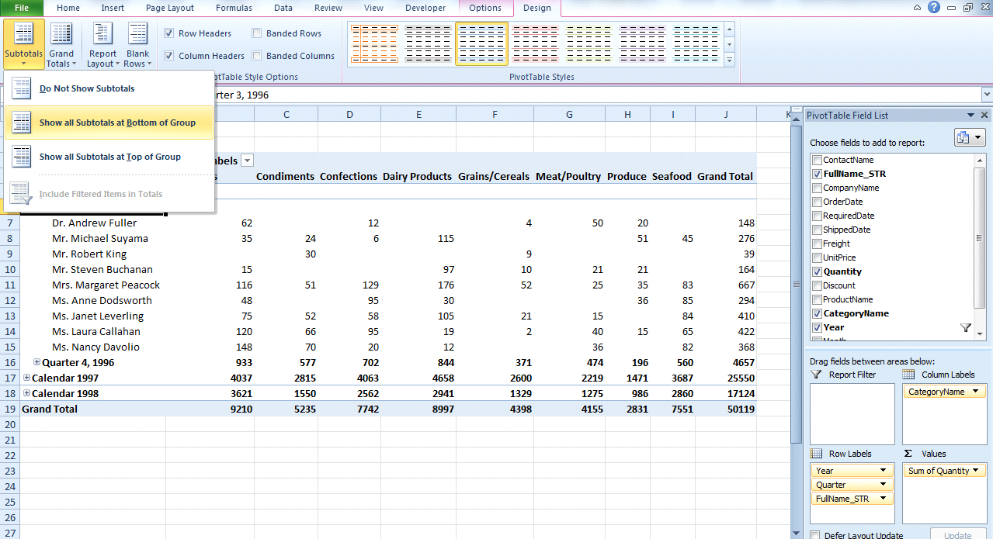

Figure 16: Output

Scenario 4: Is there any increase in sales when the products are sold ata discounted rate? Here is the answer: In the Pivot Table, drag the Year and

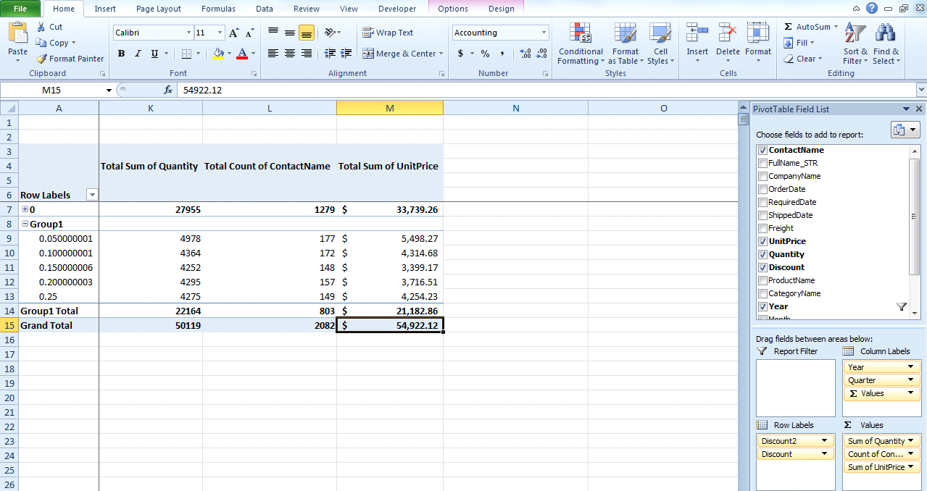

Figure 17: Output

the Quarter as Column Labels, Discount as the Row Labels and Quantity andUnit Price as Values. To see how many customers bought something at differentdiscount rates drag the ContactName to Values. You will see the ContactNameautomatically changing to Count of ContactName. The screenshot is shownbelow for reference.

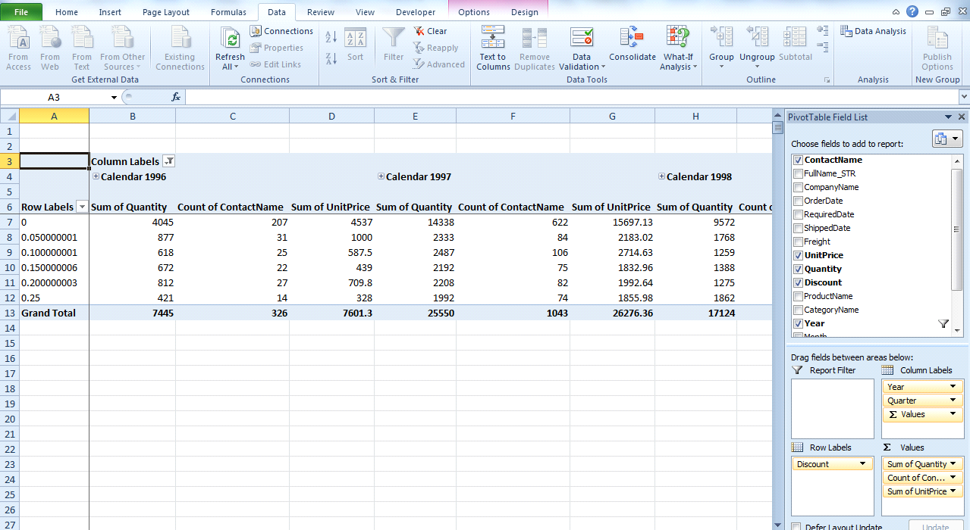

Figure 18: Output

Except for 0, ctrl select the row label and right click. You will see an optioncalled Group in the menu that appears. Select that option as shown below.Once it is selected, you will be able to see the performance of products with and without discounts.

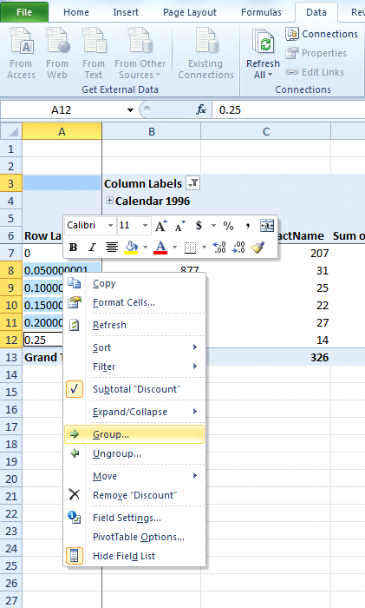

Figure 19: Output

Scenario 5: Report the sales by category and the corresponding freightcharges. Filtering should be enabled in the Year and Quarter columns, and theselected Year and Quarter need to be visible.We will take a slightly different approach to

solve this scenario. Please take alook at the below screenshot. To see the individual Years and Quarters, theconcept of slicers is used.

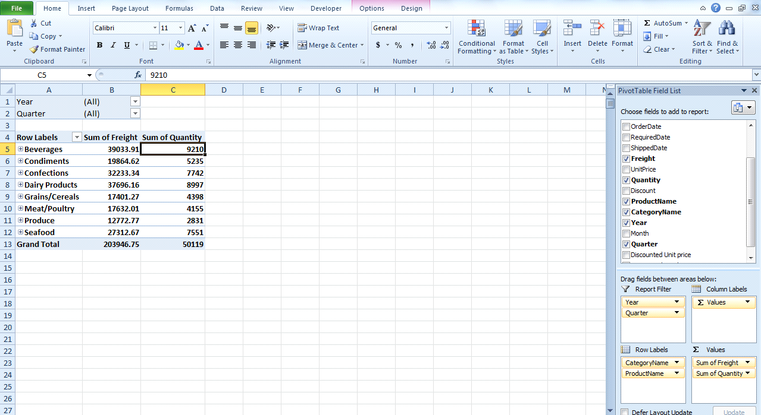

Figure 20: Output

Let‟s see how it is done: Click on the Options menuwhich gets highlighted under PivotTable Options. Click on the Insert Slicer.You will get to see the Insert Slicers window as shown. Select the Year andQuarter and click OK.

Scenario 6: Sort the Sales data in terms of Year, Quarter and Month.

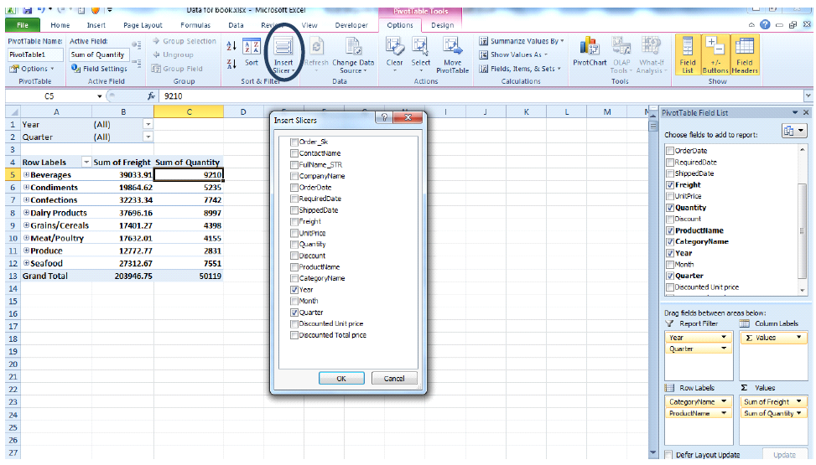

Figure 21: Output

While splitting the components of a cell make sure that the Quarter columnis cut and pasted in the neighboring column because the two outputs of thesplit will occupy the adjacent columns and if the Quarter column is not moved as described, it will be overwritten by the data as shown.

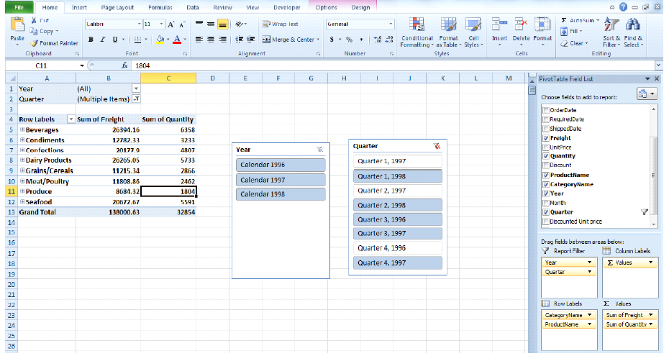

Figure 22: Output

Once the above steps are achieved, sort the Month column by Month first as shown below.

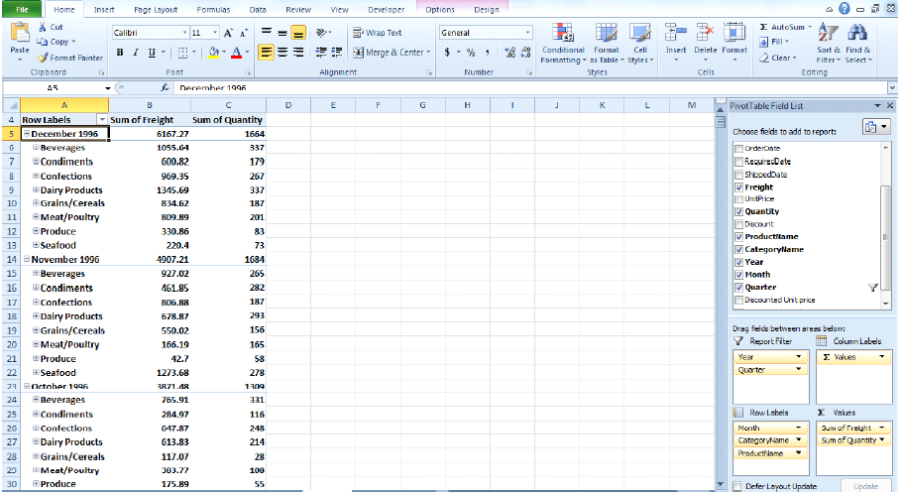

Figure 23: Output

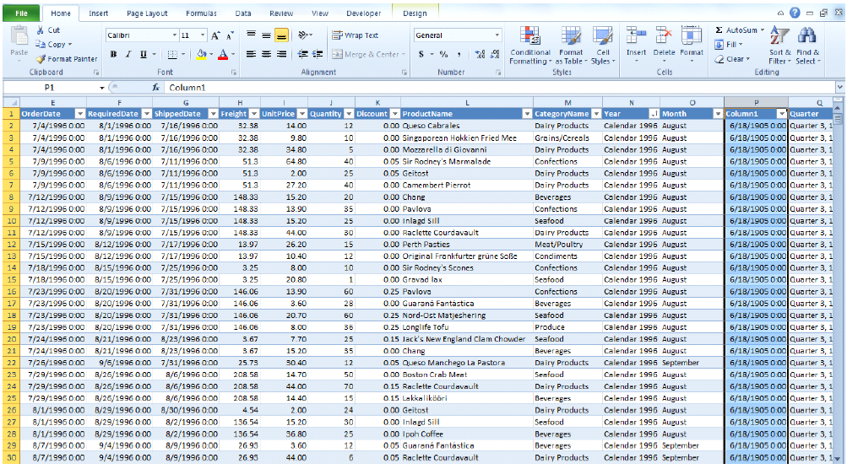

Figure 24: Output

If analysis based on the discounts is required, add 2 columns as explained below and create a new Pivot Table on this sheet. First go to the Orderssheet and create 2 new columns as shown:

Column 1: Discounted Unit Price:This column will contain the unit prices after discount. So the formula wouldbe (1-Discount)(Unit Price). In terms of excel columns the formula would be (1-J2)*(H2).

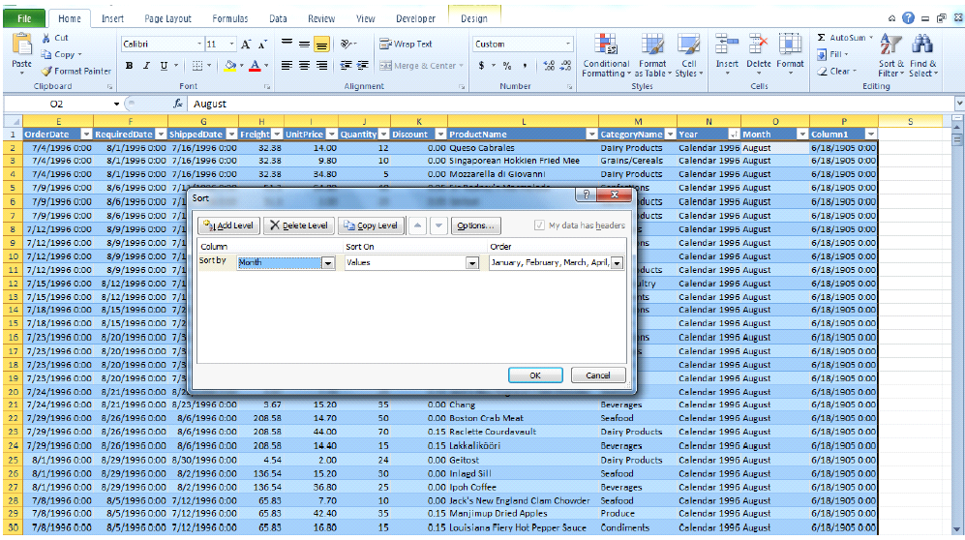

Figure 25: Output

Column 2: Discounted Total Price: This column would containdiscounted unit price multiplied by quantity. In terms of excel columns, it wouldbe P2*I2.

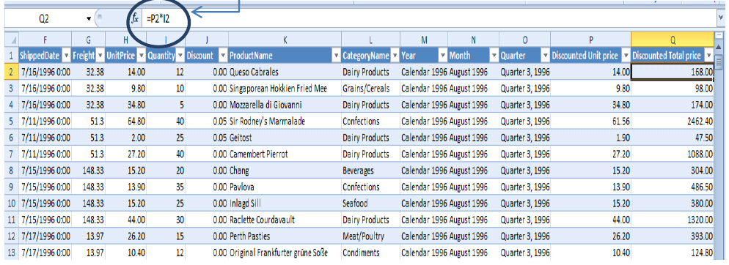

Figure 26: Output

**Conclusion:**

We have successfully studied the tool used for business intelligence and analytics tools to recommend the combination of share purchases and sales for maximizing the profit